**DATASET:**

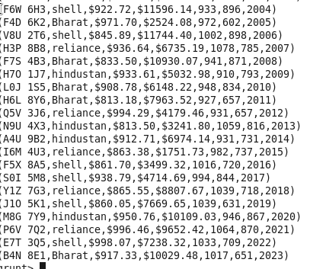

**Q1. What is the total amount of petrol in volume sold by every distributor?**



OUTPUT:



**Q2. Which are the top 10 distributors ID's for selling petrol? Also display the amount of petrol sold in volume?**

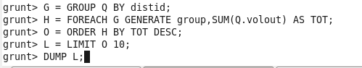

OUTPUT

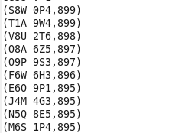

**Q.3 List 10 years where consumption of petrol is more with the distributer id who sold it.**





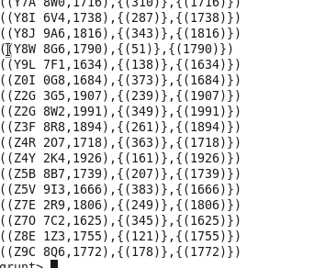



OUTPUT:

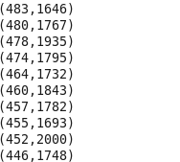

**Q4. Find the distributer name who sold petrol in least amount.**

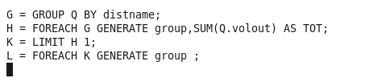

OUTPUT:

SHELL